Vihari Gardens -3

Please attach Site photos from google map
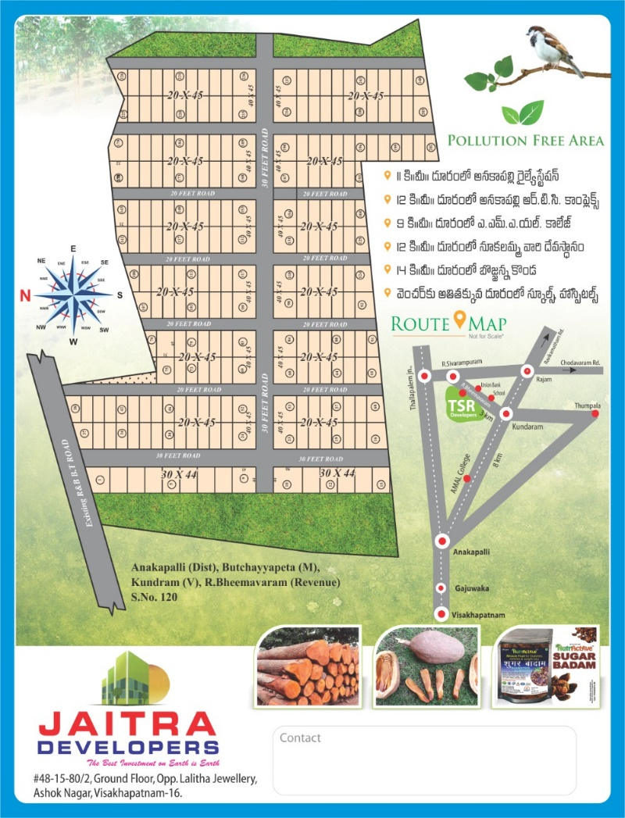


Attach LAYOUT COPY here
Layout copy should be displayed and downloadable

Project Amenities & Developments
- Mahagani Plantation project in an extent of 10 acres situated at R.bheemavaram near Kundram, Butchayyapeta mandal in Anakapalli District.
- Plots sizes starting from 100 Sq yards and all plots area as per Vastu
- Best plot size of 20’ X 45’ (suitable for individual residential building construction)
- Free Maintenance of farm lands
- All Gravel roads
- 24 hours security
- Entrance Arch
- Fencing to the entire layout
- Children play area
- Electricity and water supply

Benefits of Investing
- Project situated about 45 kms from Vizag NAD and 54 Kms from Vizag Bus stand.
- Situated very near to Anakapalle National High Way i.e., AMAL college
- Project facing 40 feet R&B road connecting from Kundram to R.Sivaram puram
- Project is just adjacent to residential area and suitable for individual Residential building construction
- All the primary amenities i.e., School, Hospital, Grama sachivalayam, Raithu barosa Kendram are hardly at a distance to 300metres from the project location
- Project is located at the core area which is at a distance of 10km for all the major areas i.e., Anakapalle NH, Thallapalem NH, Butchayyapeta Mandal Head Quarter
- Investment with very good scope of returns.
- A good investment option for guaranteed future returns.

Site Address & Location
- Vihari Gardends-3, R.Bheemavaram Revenue, Near Kundram Village, Butchayyapeta (Mandal), Anakapalle(Dist),
Andhra Pradesh - 531032
- +91-99888 38367, 84999 69716
- jaitradevelopers@gmail.com

Google Site location: https://maps.app.goo.gl/LRHmjJafE4hkXnDY6

